
  - J922074Hammitt – SuiteCommerce MyAccount Customizations

Functional Requirements Document (FRD)

Copyright© 2018, Oracle and/or its affiliates. All rights reserved.
Any reproduction or distribution of any part of this document without the prior written permission of Oracle + NetSuite is strictly prohibited.
The information included in this document is confidential and proprietary information of Oracle + NetSuite.
Version: March 3, 2022

Oracle + NetSuite
2955 Campus Drive, Suite 100
San Mateo, CA. 99403-2511

Project Information
Implementation Name | SuiteCommerce
Customer Name (Number) | Hammitt, Inc. 1040811
Job Name (Number) | J922074| MyAccount| Implementation Service
Document Owner | Mike Blakely
Project Manager | Mike Blakely
Lead Developer | Ilan Daniele

Document Version History
Rev | Date | Author(s) | Change Summary
1.0 | 7/10/23 | Mike Blakely | FRD on Payments & removal of cards
2 | 7/21/23 | Mike Blakely | Streamline via Ilan Feedback, screenshots added

Table of Contents
1 Business needs 4
2 Impacted areas/modules [Optional as output] 4
3 Acceptance criteria 5
4 Solution proposal 5
5 Prerequisites 6
6 Assumptions 6
7 Constraints and limitations 7
8 Risks 7

Business needs
Hammitt will be using SuiteCommerce MyAccount as a portal for wholesale customers to pay bills at pay.hammitt.com.
Customer wants to deliver a invoice pay portal where some customers will pay via ACH & Credit card Payments, others will not be able to pay via credit cards, and all customers cannot remove the last card on file
1) Enable You to set up restrictions/parameters for Payment Method by Customer at MyAccount checkout.
Customers who are given net terms must pay via ACH method on checkout page to lessen the transaction fee charges to Hammitt, ie these customers are given terms with the expectation that they will pay via ACH saving Hammitt a transaction fee. Customers that are Net 10, 30, 45, 60, 90 should not see “credit card” payment method.

2) Restrict Your customer from removing the last remaining credit card on file from the Customer profile.
At least one credit card must be kept on my account for these wholesale customers using SuiteCommerce MyAccount. Hammitt does not follow a cash sale process so card on file is critical to their charging of invoices.

Impacted areas/modules
This customization will impact modules MyAccount, Checkout. Also Payment Processing Files and Customer record.
On Customer record, there is going to be a custom item field called “terms”. Possible values of this fields are Net 10, 30, 45, 60, 90. Customers with value “Net 10” on terms field, will only be able to pay on checkout page via ACH method.
On MyAccount Module, the following sections will need to be modified via customization in order to fulfill the requirements:
/scs/my_account.ssp#review-payment
/scs/my_account.ssp#/paymentmethods
/scs/my_account.ssp#ach (missing this setup)
/scs/my_account.ssp#/overview

Acceptance criteria
- A customer who’s terms field is set for “Net 10, 30, 45, 60, 90”:
  - Will only see the choice to pay an invoice via ACH on review page. Credit cards option should be hidden.
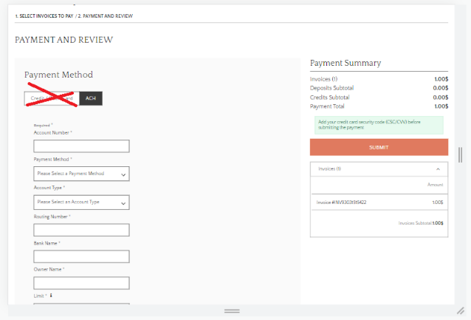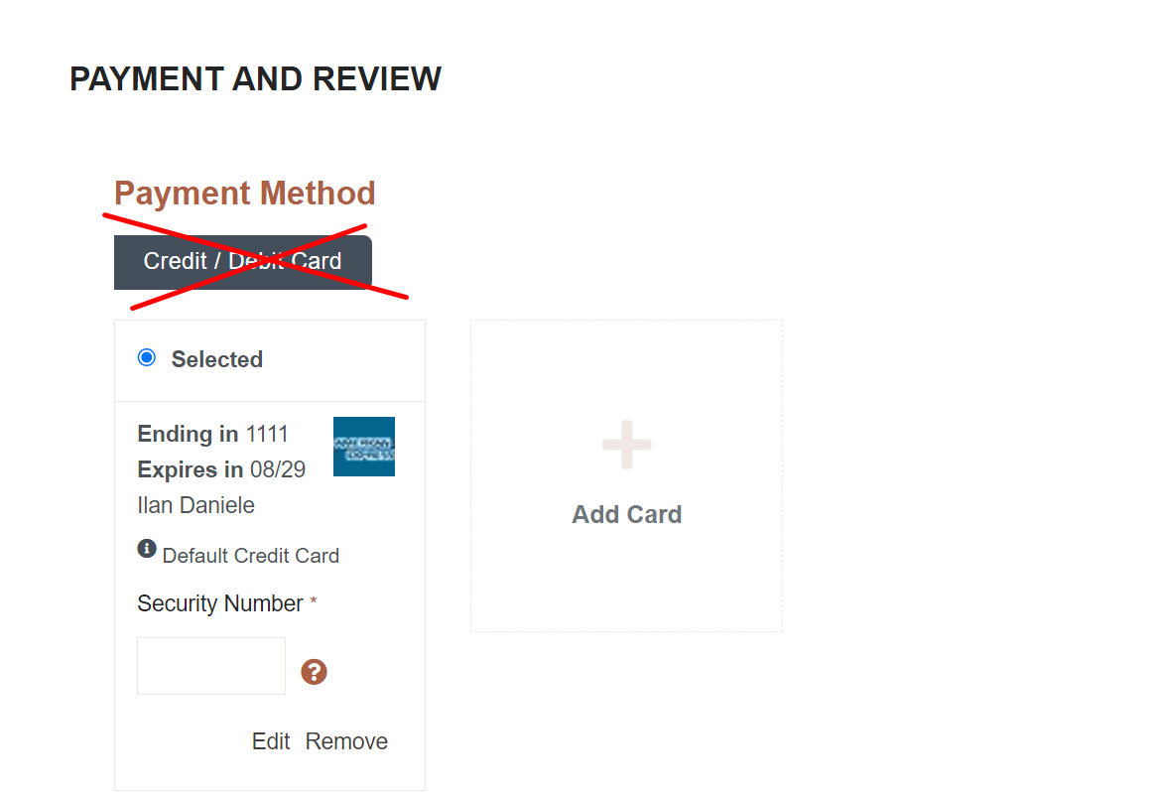
This is view: /scs/my_account.ssp#review-payment

  - Will not see “credit cards” under Settings or the payment section of Account Overview
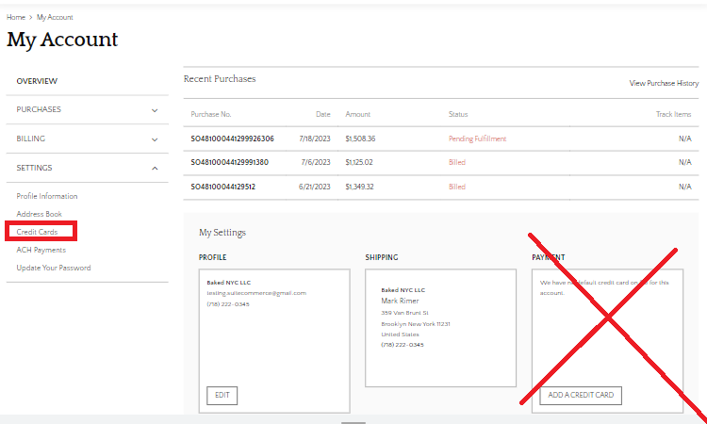
This is view: /scs/my_account.ssp#/overview

A customer who does not have net terms will see both Credit Cards and ACH when paying an invoice.
- On MyAccount section, as a customer I can remove credit cards, but when last credit card is shown, remove button should be hidden. On /scs/my_account.ssp#/overview the customer should not be able to remove their last credit card from the customer profile.
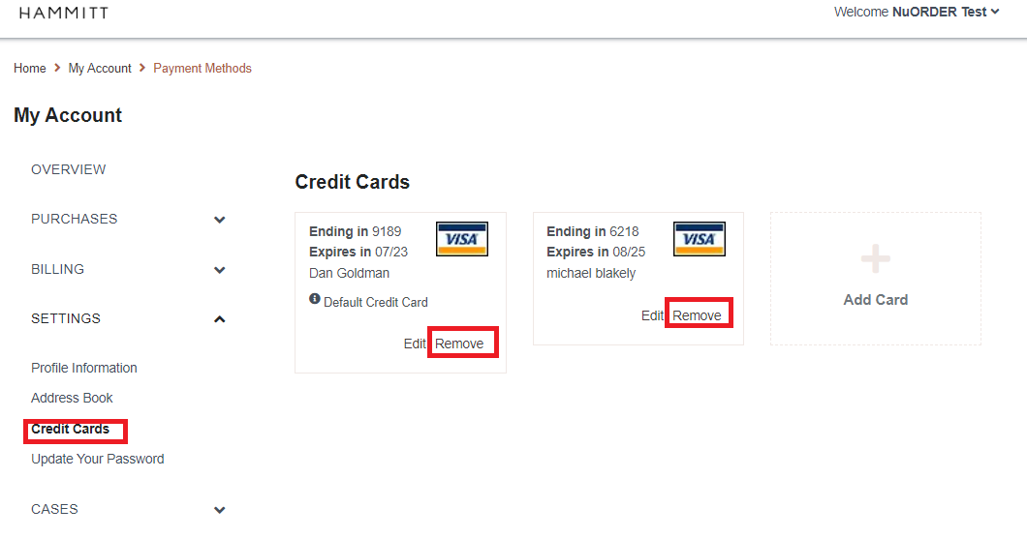
This is view: /scs/my_account.ssp#/paymentmethods

Solution proposal
Use the fields on the customer record to drive the payment processing profile shown to the customer.
The terms field on the customer record is driven off account lists.
Following values are possible values on field “terms”. These are the internal id’s to value on the clients account that need to be restricted from paying invoices via credit cards.
Internal ID | Terms | Action
12 | Net 10 | Only Show ACH (Hide Creditcards at Review Payment), Hide Menu for Credit Cards
1 | Net 15 | Only Show ACH (Hide Creditcards at Review Payment), Hide Menu for Credit Cards
2 | Net 30 | Only Show ACH (Hide Creditcards at Review Payment), Hide Menu for Credit Cards
17 | Net 45 | Only Show ACH (Hide Creditcards at Review Payment), Hide Menu for Credit Cards
3 | Net 60 | Only Show ACH (Hide Creditcards at Review Payment), Hide Menu for Credit Cards
16 | Net 90 | Only Show ACH (Hide Creditcards at Review Payment), Hide Menu for Credit Cards

Prerequisites
- Client will set up customer record’s terms field.

Assumptions
- The terms values and ids remain unchanged.
- ACH payment method should always be available otherwise there won’t be any payment method to choose and customer won’t be able to place the order.

Constraints and limitations
- The last card on MyAccount section removal button hide logic will not look at expiration dates, if it’s just the last card it cannot be removed.

Risks

Oracle + NetSuite Professional Services and Customer are in agreement that the information documented above is accurate and representative of the customer’s business needs. This document will act as the basis for all subsequent implementation activities.
Document delivery date: 7/21/2023

